  St Petersburg School of Conference Interpreting and Translation | International conference  Fighting the Fog in Multilingualism:  the Importance of Clear Writing and Speaking in Intercultural Relations  4-5 March 2013 | 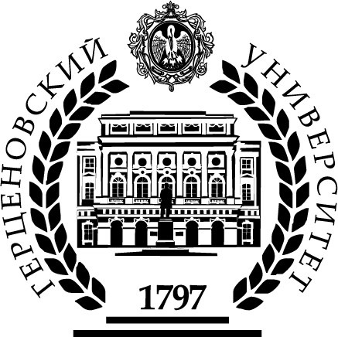  Herzen State Pedagogical University of Russia

REGISTRATION FORM

Deadline for registration is February 25, 2013

First name

Family name

Job title

Institution

Mailing address

Contact phone
(with country code)
Fax
(with country code)
E-mail

Date of arrival at St. Petersburg
Date of departure from St. Petersburg
Herzen University Hotel reservation  Is yes, then the dates | Yes No
Please write your name as you wish it to appear on your badge

Please complete and return your registration form to Herzen University
E-mail: spbs@herzen.spb.ru

Deadline for registration is February 25, 2013

Information

The working languages of the conference: English and Russian

